**AssignmnetNo.3**

**Question - 1:**

**Create a numpy array starting from 2 till 50 with a stepsize of 3**

**Code:-**

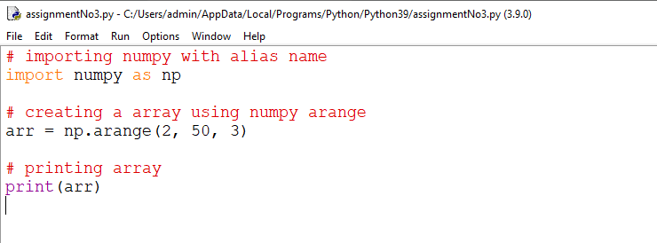

**OUTPUT:-**

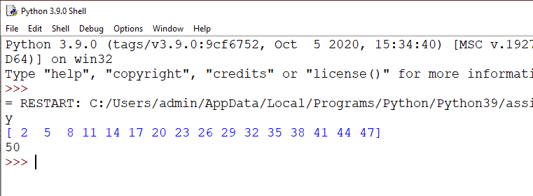

**Question - 2**

**Accept two lists of 5 elements each from the user. Convert them to numpy arrays. Concatenate these arrays and print it. Also sort these arrays and print it.**

**Code:-**

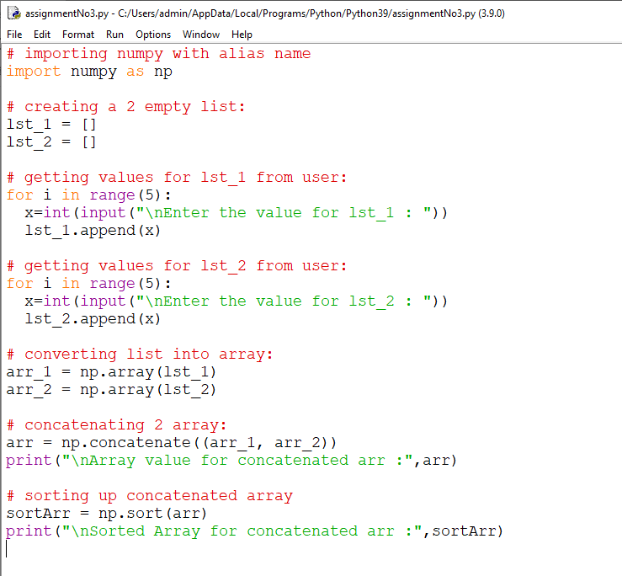

**OUTPUT:-**

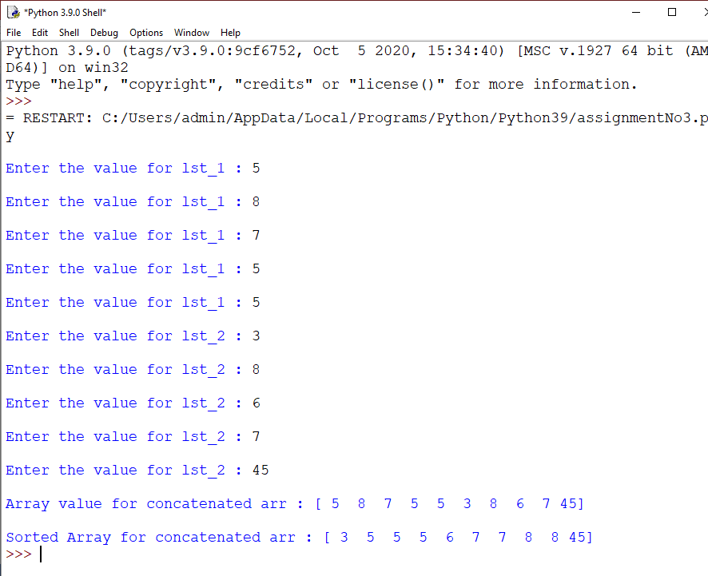

## Question - 3:

#### Write a code snippet to find the dimensions of a ndarray and its size.

#### snippet for finding dimension:

ArrayName.ndim

#### snippet for finding size:

ArrayName.size

**CODE:-**

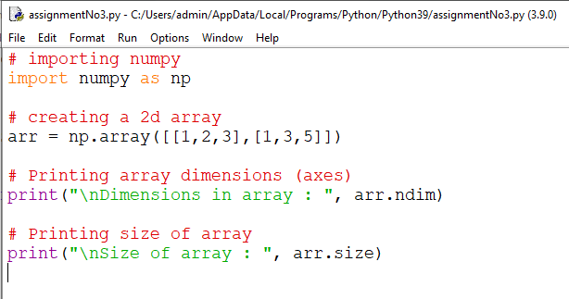

**OUTPUT:-**

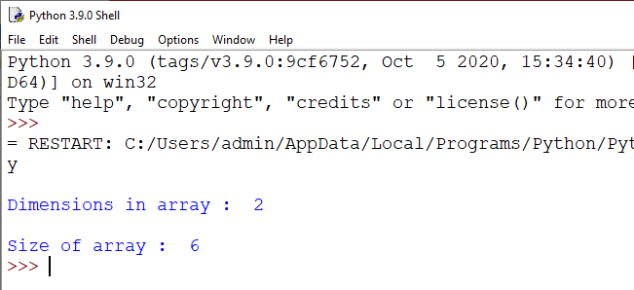

## Question - 4:

#### How to convert a 1D array into a 2D array? Demonstrate with the help of a code snippet

##### *Hint: np.newaxis, np.expand_dims*

### newaxis snippet:

ArrayName[numpy.newaxis, :] // row major

ArrayName[:, numpy.newaxis] // column major

**CODE:-**

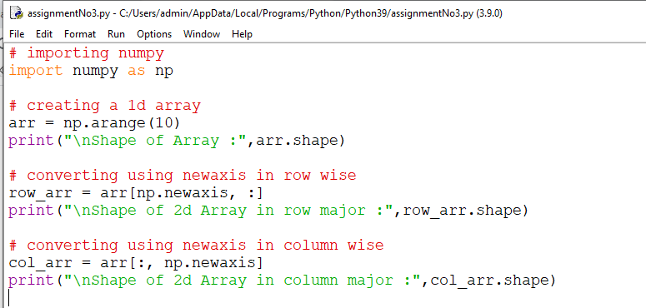

**OUTPUT:-**

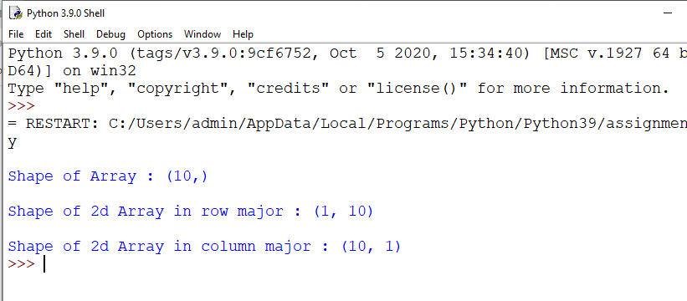

### **expand_dims snippet:**

numpy.expand_dims(ArrayName, axis = 0) // row major

numpy.expand_dims(ArrayName, axis = 1) // column major

**CODE:-**

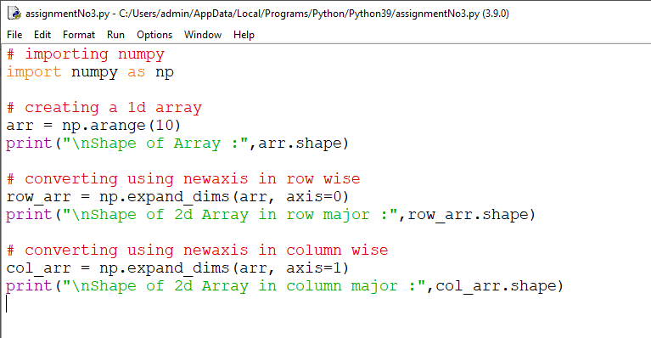

**OUTPUT:-**

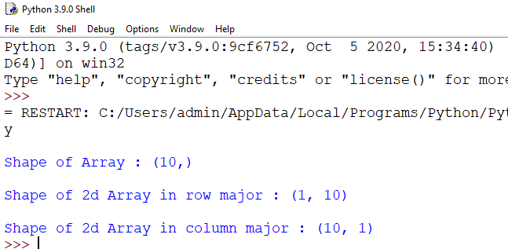

## Question - 5:

#### Consider two square numpy arrays. Stack them vertically and horizontally.

##### *Hint: Use vstack(), hstack()*

**CODE:-**

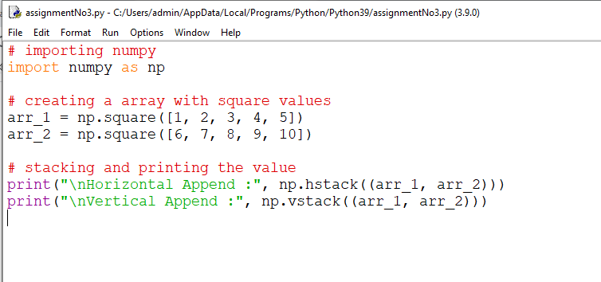

**OUTPUT:-**

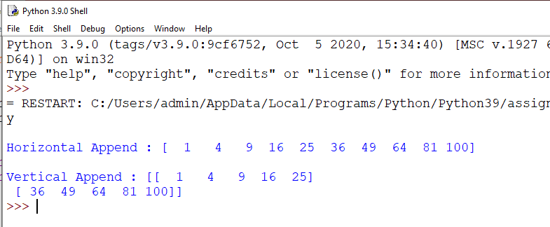

## Question - 6:

##### *How to get unique items and counts of unique items?*

unique method in numpy is used to get the unique values from the list and return count attribute of unique method return the count of unique value from the list.

**CODE:-**

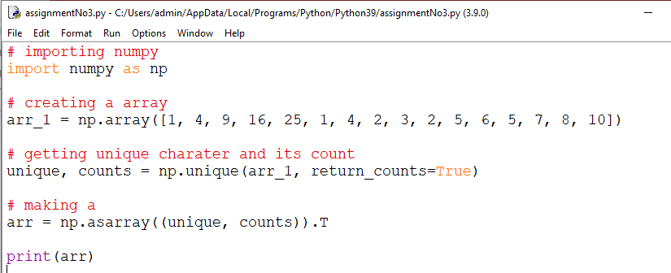

**OUTPUT:-**

